Contestant Number: ____________________
Time: ___________________
Rank: _______________



Fundamental Accounting
(100)

NATIONAL 2024

CONCEPT KNOWLEDGE:

Multiple Choice (40 @ 2 points each) ________________ (80 points)
APPLICATION KNOWLEDGE:
Short Answer (15 @ 3 points each) ________________ (45 points)
Job 1: Depreciation ________________ (36 points)
Job 1: Inventory Costing ________________ (41 points)
Job 2: Effects on Net Income ________________ (48 points)

TOTAL POINTS ________________ (250 points)

Test Time: 90 minutes

GENERAL GUIDELINES:
Failure to adhere to any of the following rules will result in disqualification:
- Member must hand in this test booklet and all printouts if any. Failure to do so will result in disqualification.
- No equipment, supplies, or materials other than those specified for this event are allowed in the testing area. No previous BPA tests and/or sample tests (handwritten, photocopied, or keyed) are allowed in the testing area.
- Electronic devices will be monitored according to ACT standards.
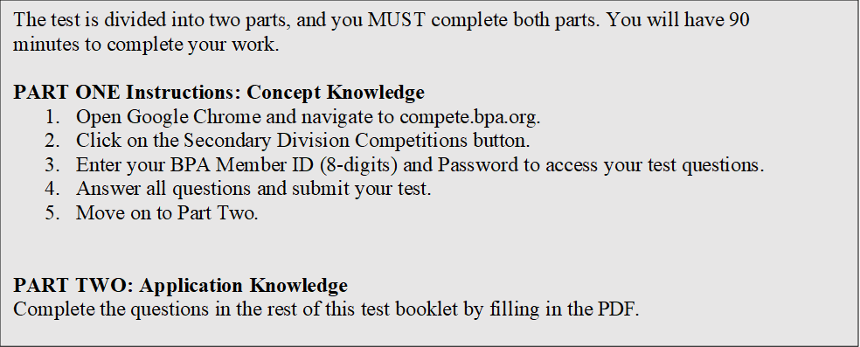

EXAM GUIDELINES:

You have been hired as a Financial Assistant and will be keeping the accounting records for Digital Solutions, located at 700 Morse Road, Suite 201, Columbus, Ohio 43214. Digital Solutions provides accounting and other financial services for clients. You will complete jobs for Digital Solutions’ own accounting records, as well as for clients.

You will have 90 minutes to complete your work. The test is divided into two parts: concept knowledge and application knowledge.

Your name and/or school name should not appear on any work you submit for grading. Write your Member ID in the provided space. Staple all pages in order before you turn in your test.

Assumptions to make when taking this assessment:
- Round all calculations to two decimals at the final step.
- Round all percentages to one decimal place.
- Use 360 days for interest calculations.
Short Answer Problems – 45 Total points
- Clapton Food Suppliers has the following aging of its accounts receivables at the end of the year. Below each is the estimated percentage that will be uncollectible, based upon the category. The Allowance for Uncollectible Accounts before adjusting entries has a debit balance of $450.

Account Balance Current 1-30 31-60 Over 60
Total $41,800 $23,800 $14,600 $1,000 $2,400
Percentage 0.5% 1.5% 20% 50%
  - What is the total estimated uncollectible accounts?

  - What account will be debited on the adjusting entry?

  - What account will be credited on the adjusting entry?

  - What is the amount of the end of the year adjusting entry?

- Hendrix Corporation accepted a 90-day, 6.5% note from a customer on an outstanding accounts receivable balance of $1,640 on November 25th, 2023.

  - What accounts make up the entry on November 25th?
Debit

Credit

  - How much interest did Hendrix earn in 2023?

  - How much interest did Hendrix earn in 2024?

  - What is the maturity date?

  - What is the maturity value?

  - What accounts are credited on the maturity date?

- Page & Associates, Inc. shows the following data for 2024.
Beginning Capital Stock – 25,000 shares $10 par, total $250,000
Issued on May 1st – 5,000 shares, $10 par @ $12 per share, total $60,000
Beginning Retained Earnings - $324,800
Net Loss for 2024 - $63,600
Dividends declared during 2024 - $0.15 per share, January 3rd and April 3^{rd;} $0.10 per share on July 3rd and October 3rd.

    - How much did Page declare in dividends for 2024?

    - What is the net decrease in Retained Earnings for 2024?

    - What is the ending balance of Retained Earnings?

    - Balance of Stockholders’ Equity shown on the Balance Sheet

Job 1 – Depreciation – 36 points total.
Directions: Use the following information to complete a depreciation table for both the straight line and double-declining balance methods of depreciation. Then answer the questions that follow.
Richards Music Co. buys a piece of equipment on January 6, 2024 for $18,200. The equipment has a four-year life, at which time the expected salvage value is $2,100.
 | Straight Line |  |  | Double-declining Balance
 | Annual  Depreciation | Accumulated  Depreciation | Ending Book  Value | Annual  Depreciation | Accumulated  Depreciation | Ending Book  Value
2024
2025
2026
2027

- If the equipment was sold on December 31, 2025, for $6,775, how much of a gain would you recognize, assuming double-declining balance?

- If the equipment was purchased on March 28, 2024, what would be the depreciation for 2024, assuming straight-line depreciation?

- If the equipment was purchased on March 28th, 2024, what would be the depreciation for 2024, assuming double-declining balance?

- If the equipment was sold on October 5th, 2026, for $4,200, how much of a loss would you recognize, assuming straight-line?

Job 2 – Inventory Costing – 41 points total.
Santana Supply Store shows the following beginning inventory and purchases for 2024. Use FIFO, LIFO, and Weighted Average to find the cost of ending inventory. Follow the directions for each costing method.
Directions for FIFO Table 1: Find the Total Cost for beginning inventory and each purchase in the table below. Using the ending inventory quantity of 47, determine FIFO units on hand and FIFO cost. Total the units purchased, total cost, FIFO units and FIFO cost columns. Show the total FIFO cost below the table.
Purchase  Dates | Units  Purchased | Unit  Price | Total  Cost | FIFO Units  On Hand | FIFO  Cost
Jan 1 beginning inventory | 8 | 14.25
Feb 14 purchase | 15 | 15.31
May 23 purchase | 22 | 15.35
Oct 12 purchase | 20 | 16.10
Dec 6 purchase | 18 | 16.24
Totals

Total FIFO Cost of Ending Inventory

Directions for LIFO Table 2: Find the Total Cost for beginning inventory and each purchase in the table below. Using the ending inventory quantity of 47, determine LIFO units on hand and LIFO cost. Total the units purchased, total cost, LIFO units and LIFO cost columns. Show the total LIFO cost below the table.
Purchase  Dates | Units  Purchased | Unit  Price | Total  Cost | LIFO Units  On Hand | LIFO  Cost
Jan 1 beginning inventory | 8 | 14.25
Feb 14 purchase | 15 | 15.31
May 23 purchase | 22 | 15.35
Oct 12 purchase | 20 | 16.10
Dec 6 purchase | 18 | 16.24
Totals

Total LIFO Cost of Ending Inventory

Directions for Weighted Average: Using the information from the tables above, find the ending inventory cost using the weighted average method.
Total Weighted Average Cost of Ending Inventory

Job 3 – Effects on Net Income – 48 points total.

Directions: Selected transactions for Gibbons Industrial Cleaners, Inc. are shown below. Analyze each transaction and its effect on the 2024 Income Statement. Determine whether the effect is an increase to net income, a decrease to net income, or has no effect on net income for the year 2024. Then identify the amount of the increase or decrease. If no effect, enter zero.

- February 1 – Paid $5,800 cash for January utility usage.
- March 1 – Issued 125,000 shares of $5 par value stock for $7.
- March 15 – Bought $5,000 worth of advertising, paying cash in full.
- April 4 – Purchased equipment with a $47,000 cost, paying cash in full. The equipment has a useful life of 5 years, with a salvage value of $7,000.
- July 16 - Sold $12,000 worth of cleaning services to Jeff Becker on account, plus 7.5% sales tax. Terms of sale were 2/10, n/30.
- July 25 – Received cash from Jeff Becker on account to pay what was owed from the July 16th sale.
- September 1 – Declared a dividend of $0.80 per share. Gibbons has 875,000 shares of stock issued and outstanding.
- October 1 – Paid amount owed on dividend from September 1 declaration.
- November 1 – Received $6,000 for 3-month storage rental.
- November 11 – Received a 90-day, 7% promissory note from Nancy Wilson for past-due accounts receivable in the amount of $4,500.
- November 20 – Received bankruptcy notice on Jayden Prince. Jayden had a $830 accounts receivable balance. Gibbons Industrial Cleaners uses the Allowance method of Accounts Receivable.
- December 1 - Performed cleaning services for Derringer Auto worth $4,600, plus 7.5% sales tax. Jensen paid cash at the time of the services.

Transaction Number | Effect on Net Income -  Increase, Decrease, None | Amount of Effect
1
2
3
4
5
6
7
8
9
10
11
12

